Nama : Lilis Sonia

NIM : 18090051

Kelas : 5D

**PRAKTIKUM 2**

1. Source Code

latihan1-> application/controller/latihan1

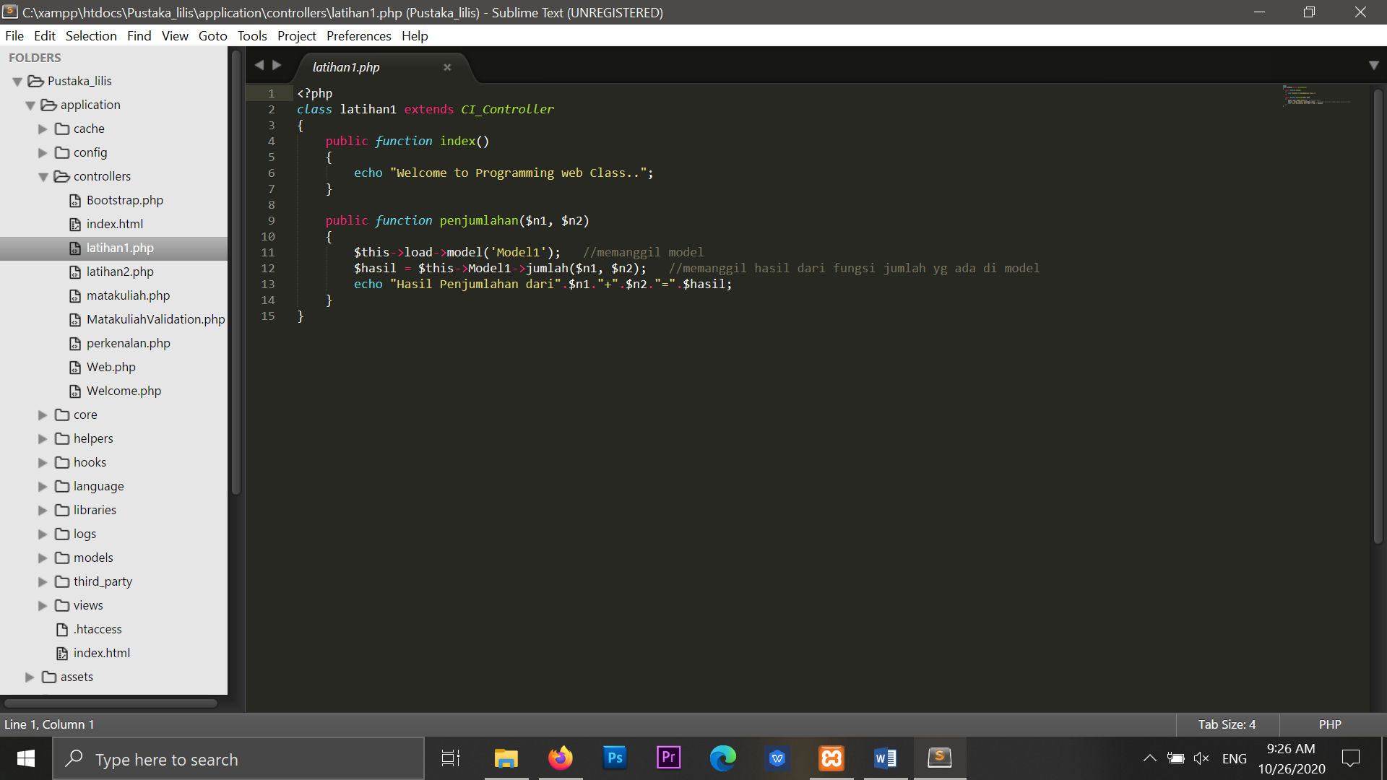

latihan2 -> application/controller/latihan2

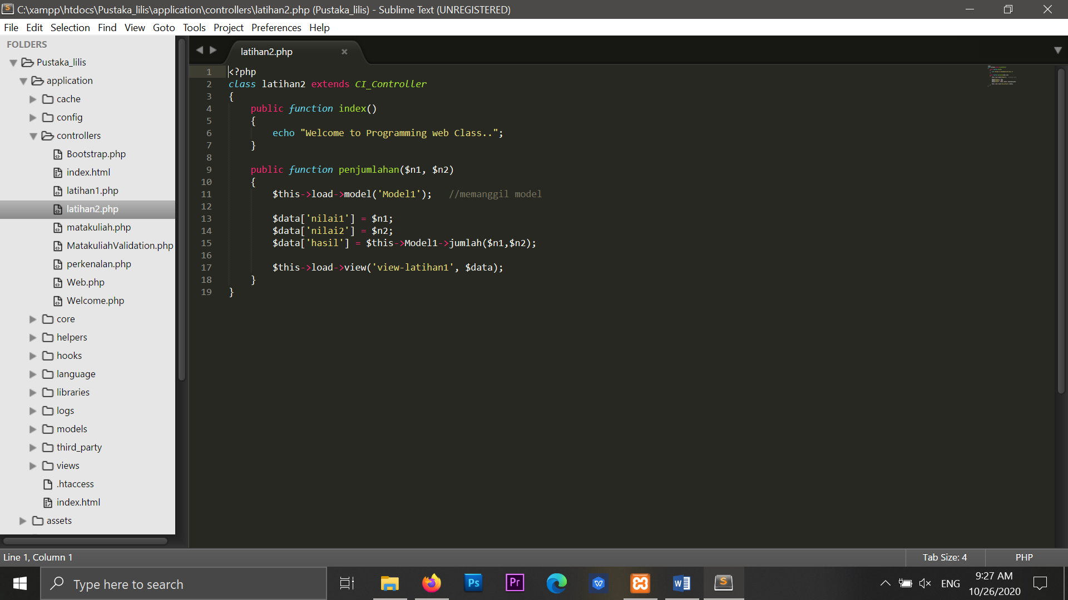

model1 -> application/models/model1

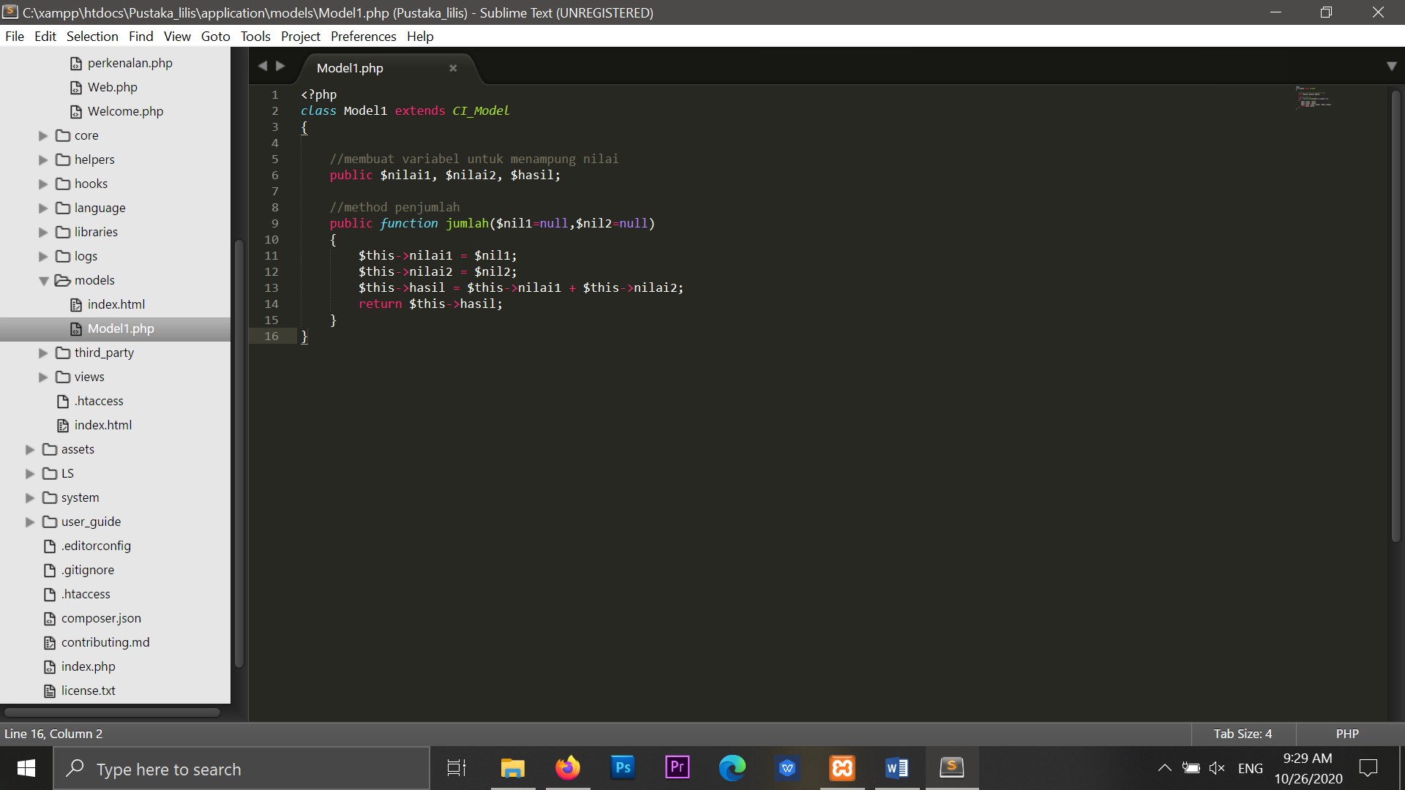

View-latihan1.php->application/views/view-latihan1

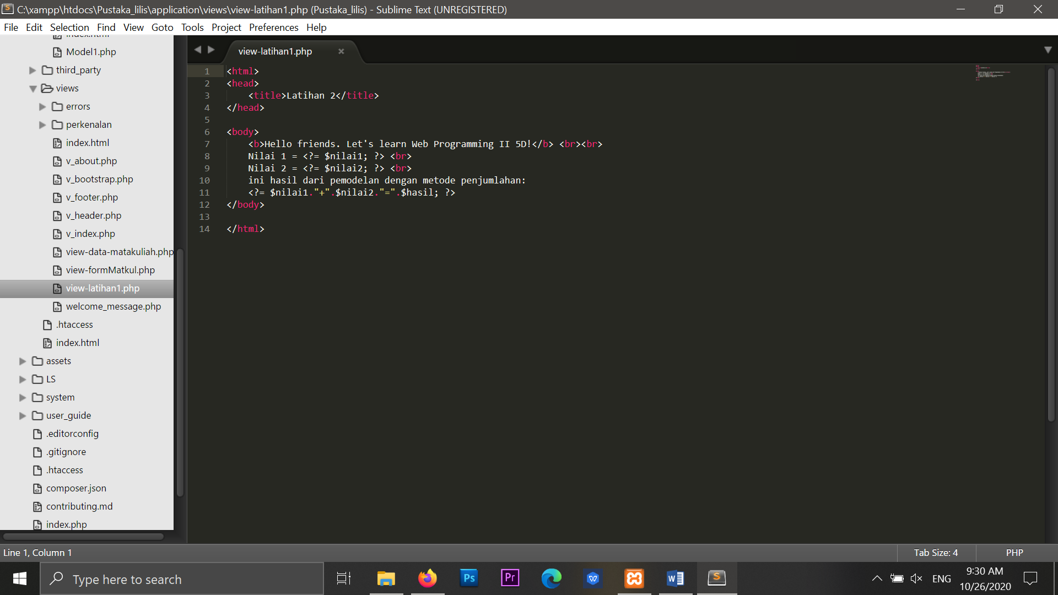

1. URL

* <http://localhost/Pustaka_lilis/latihan1>
* [http://localhost/Pustaka_lilis /latihan2](http://localhost/Pustaka_lilis%20/latihan2)
* [http://localhost/Pustaka_ lilis /latihan2/penjumlahan/3/6](http://localhost/Pustaka_%20lilis%20/latihan2/penjumlahan/3/6)
* [http://localhost/Pustaka_ lilis /latihan1/penjumlahan/4/5](http://localhost/Pustaka_sammal/index.php/latihan1/penjumlahan/4/5)

1. Capture Hasil

**Hasil run latihan 1**

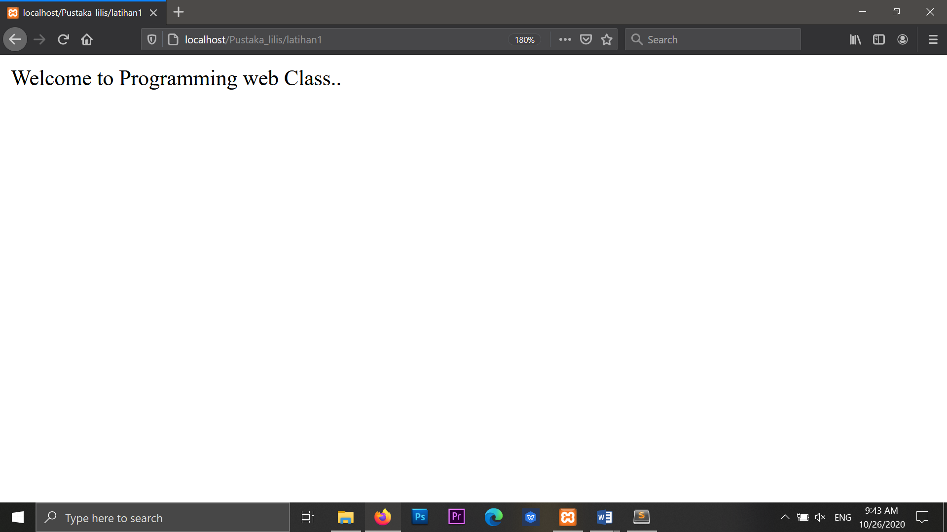

**Hasil run latihan 2**

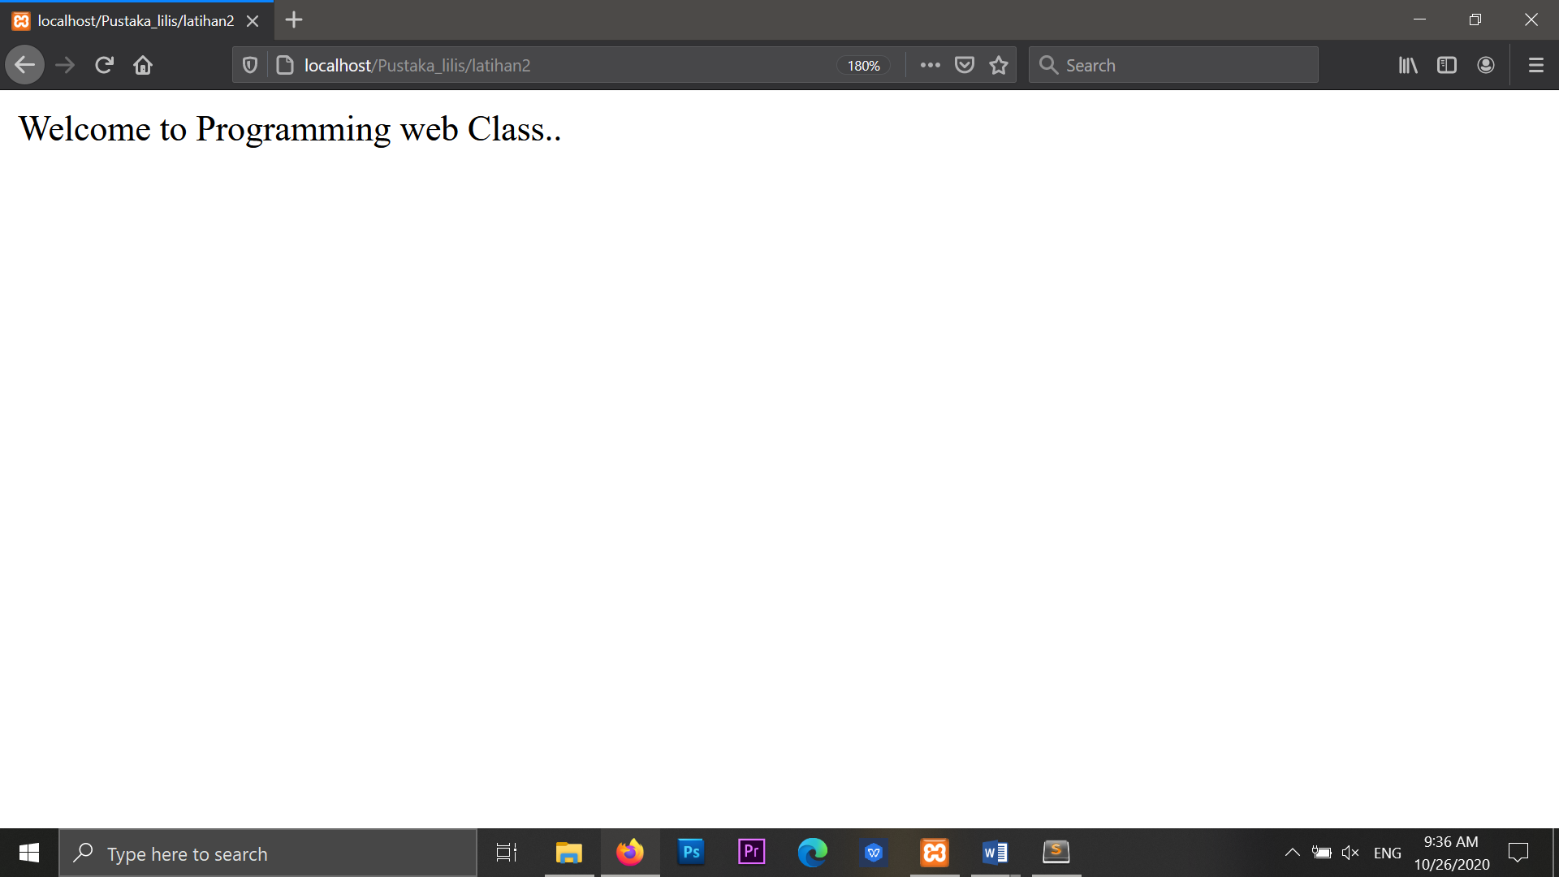

**Hasil run penjumlahan**

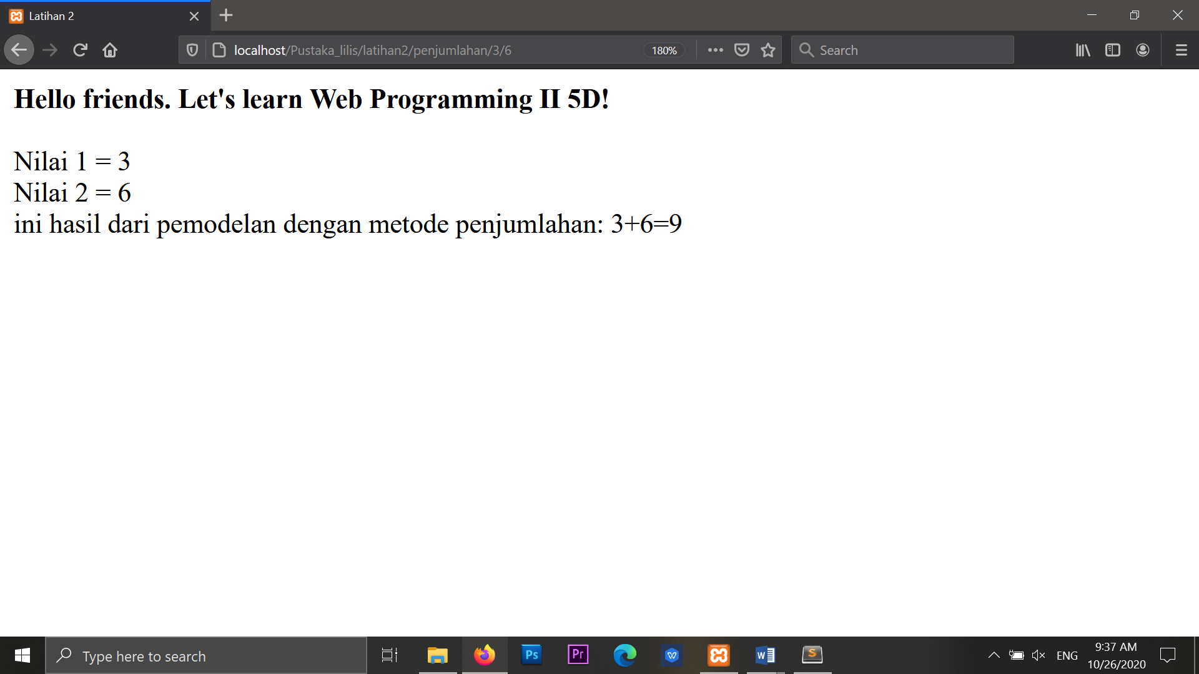

**Hasil run latihan 1**

